

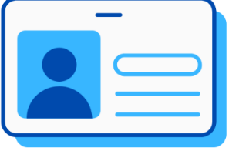

Step 8
Manatee County and Sarasota County Public School Students: You must return your books to the SCF Bookstore by the second week of class in the following semester.

Private/Homeschool/PEP Students: You must return your books to the SCF Bookstore by the second week of class in the following semester.

Charlotte County Public School Students: You must return your books to your high school at the end of the semester.
Step 4
Scan QR code at the bookstore and enter G00# to receive list of required textbooks. Early College students are required to choose the digital version of materials if available.

Step 5
Bring the materials and your student ID to check out at the register. Identify yourself as an Early College student. Early College students do not pay for required materials. You will receive instructions on how to use access codes to activate digital materials.
Step 6
Follow up with the bookstore if you add or drop classes.
Step 7
If you have any issues activating digital materials, contact the bookstore for assistance as soon as possible. You can email BookstoreManager@SCF.edu or call 941-752-5080.
Step 3
Go to either campus store. Identify yourself as an Early College student.
Venice Campus Office - Building 500
Bradenton Campus Office - Building 14
Step 2
Go to the Public Safety Office to pick up your SCF Student ID Card.
Venice Campus Office - Building 500
Bradenton Campus Office - Building 14
Step 1
Continually monitor your SCF student email for communications from
the bookstore, Follett, and the office of Early College.
SCF Early College Textbook Procedure

